MPower Award Nomination for **Jacqueline Monetta**

Submitted by Kiki Goshay

I am certain that there is no one more deserving of the MPower award than Jacqueline Monetta. Her journey not only changed my life, but will change the lives of everyone who sees her film or meets her.

My teenage neighbor, Jacqueline, came to me during her senior year in high school. She knew I was a film producer. She came to me for advice. She told me she was making a film to end teen suicide. “Lofty.” I thought. She explained that her best friend had taken her life during their sophomore year. Six teens in the area had also died by suicide. As a parent of a teen in the same neighborhood, I was very aware of these suicides and what appeared to be a disturbing trend.

Jacqueline then explained to me her frustration that no one seemed to be talking to teens about it in a way that resonated with them. They had some school programs, but teens were immune to messages like “just say no” campaigns. These messages were coming from adults who couldn’t possibly know the realities of teen life. Easy for them to say “just say no”, when they haven’t been to a teen party today. The messages were easy to dismiss because they were so disconnected.

Jacqueline didn’t know much about suicide and never thought about depression until her friend died. She had not experienced depression so she couldn’t truly imagine the feelings her friend had to have to take her life. She was determined to understand. After she exhausted everything available on the internet, she sought information and involvement with local suicide prevention groups. She joined a peer group, Sources of Strength, at her school. She met with organizations focused on suicide prevention. She learned the vernacular and became an expert on speaking to someone who is suicidal.

By the time she came to me, she had been immersed in suicide prevention for 2 years. I asked her about her film experience. She said she did not have any. But she was determined to make a video because that is how one reaches teens these days. She explained that her peers garnered their information from video and the internet. Her mission was to reach teens experiencing depression and suicidal thoughts. She felt they needed to know that they weren’t alone. She thought the best way to give them hope, was to hear this from another peer who had gone through the same thing.

With the help of some school friends, she shot a short teaser for her film, Not Alone. She envisioned something a bit longer with a few more teens in it. But basically her idea was simple. Teens who had experienced depression or had attempted or thought about suicide share their stories. Teens experiencing depression needed to know that they weren’t broken, weird, doomed. They would realize they weren’t alone if they heard it and saw real teens who had experienced it. Teens who did not have depression would be educated and therefore more compassionate and helpful to their peers. Essentially, she wanted to change the culture of the teen world so that mental health was something they could all talk about and support.

When I watched her short video clip, I was pulled in. Because these teens were speaking to her, they were raw and honest. I saw a unique opportunity in supporting Jacqueline’s mission to give teens a voice. She was able to give us an insider’s vantage point.

I also saw something Jacqueline couldn’t see. She needed to be in the film. Her own story and her empathy added an important element and message. She represented the “friends” who care and can make a difference. Directed by her innate compassionate nature Jacqueline operated like someone coached in active listening and validation. I saw this before we shot any of the interviews. I witnessed it when I sat with her as she met with peers who responded to her search for teens willing to share their stories. She didn’t need to be trained or coached. Her concern and openness and desire to embrace those she was meeting was authentic and palpable.

She was confident and persistent in finding teens eager to share their stories on film. I can’t imagine any of them would have come forward or would have felt comfortable exposing themselves with anyone other than Jacqueline. They knew she was coming from a place of love and concern and a desire to make things better for others. Many of them had never met Jacqueline. But she connected with each teen and related like a friend.

I knew this would be a challenging project. I was going to support a director who didn’t even understand the process of filmmaking. To truly represent the teen voice and vantage point, I needed to empower her to direct. While Jacqueline was resolute to her vision, she was open to input from the professional crew I assembled for her. She easily collaborated as we planned a look and feel for her interviews.

When we shot the interviews, she blew me away. She was emotional, real and supportive. She asked all the questions she would have liked to ask her friend. And she listened.

She sensed that social media and the constant electronic connectedness may contribute to some of the problems her peers were having. She asked about them pros and cons of social media.

We had 20 hours of powerful interviews when we finished. And then the real work began. We had to create one story out of all of this. This was a long and difficult process. I think it was during this process that Jacqueline and I learned the most, as we fleshed out what the film could and should do.

I also learned so much about Jacqueline. I witnessed her process the death of her friend. I saw that she felt guilty for not seeing the warning signs. For not pushing and asking even though she saw some things that troubled her. I felt she took on the burden of blaming herself for not acting, even though she didn’t know anything about mental illness at the time. She thought if she had known, her love and attentive listening would have saved her. The teens she interviewed are the ones who set her free. They emphasized that friendship alone didn’t save them. They needed professional help.

All of the information we needed came directly from the interviews. The teens covered everything from how mental illness feels, self-harm, drug and alcohol abuse, suicidal ideation, suicide attempts, getting help and maintaining their mental health. Part of my process was to connect with mental health professionals and educators. I realized we had a treasure trove of information that would allow us to go further than Jacqueline’s original embracing message. These interviews yielded everything we needed to create a suicide prevention tool, complete with signs of mental illness, warning signs of suicide, how to talk to someone thinking of suicide and getting help.

Jacqueline was open to broadening the scope and including an emphasis on reaching out to adults for help or bringing a friend to an adult for help. I know when she came to me with this project, at 18 years old, she thought teens could be the ones to listen to each other and help each other. When we locked the picture, she still felt strongly that teens could help each other. But she had grown to see that they couldn’t do it on their own. They had to be open to getting adult, professionals involved.

With the film in the can, Jacqueline is energized to get its message out. She is hosting a screening at her school, Duke University next month. She will travel to be on panels at screenings. She is involved in creating a Mental Health Awareness month at Duke. She continues to reach out to professionals, students and organizations to get Not Alone into the schools and community screenings. Thanks to Jacqueline, I’ve stretched myself both professionally and emotionally. I am committed to pushing until every teen has seen her film. Not Alone has an educational distributor. Together we will try to get the film and curriculum into every middle school, high school and college. It takes tenacity and commitment for anyone to make a film. Imagine the dedication it took for a teen to convince adults to give their time, money and professional skills to an 18 year old girl with no film experience. Please visit our website [www.not-alone.live](http://www.not-alone.live)

Following is a brief bio and Jacqueline’s story which she wrote during the making of the film Not Alone.

Jacqueline Monetta is a student at Duke University studying Public Policy and receiving two certificates in Documentary Studies and Policy, Journalism, and Media Studies. She is a senator for the Equity and Outreach Committee for the Duke student government and specifically works on policy and events surrounding mental health awareness, sexual assault prevention, and multiculturalism. She is a student research assistant for the Duke's Rutherford Living History program and a member of the Duke Association for Business Oriented Women. As a member of a film organization entitled Students of the World, Jacqueline directs her efforts toward filmmaking to spark social and political change.

*This is for those who want to be apart of the Not Alone journey*.

**Not Alone**

My Story with Quinn Van Bergen

By Jacqueline Monetta

I have put off writing this for quite some time now, two years, and seven months to be exact. And yet, I sit down tonight with a blank screen in front of me and a million of thoughts, but no words. It’s funny how your mind can race in all directions, but when you have to write or talk, you have nothing to say. This is for all the teens that have so much to say with no voice.

I am who I am today because of a girl name Quinn. Quinn could make me laugh to a point where my stomach would ache and usually in the most inappropriate places, at the most inappropriate times. In fact, sometimes I would have to tell myself, “Do not look at her,” because I knew if I did I would burst out laughing in the middle of church or class. She was “basic” in the way she loved pumpkin spice lattes and UGGs but unique in the sense that people were just drawn to her and wanted to be her friend. The best days with Quinn weren’t the days of big events, but rather the days we spent watching a movie together on a Friday night, having a lunch date at school, attempting to make a Coke bottle explode with Mentos, spending several hours playing the piano, and telling countless stories. She helped me enjoy small moments no one pays attention to and helped me realize to not take life so seriously because no matter what we did, she was always smiling. She became the sister I never had. She was immensely loved by her supportive family and cherished by her friends.

But that day she didn’t see it. She didn’t know how much everyone loved her. She didn’t feel like she could talk to me, to our friends, or to her family. She didn’t know I would do anything for her to take back her decision. Because on that day, October 27, 2011, Quinn took her life leaving me with questions I thought I never would have answers to.

**October 27, 2011:** On Thursday morning, I answered my phone effortlessly not knowing it would change my life. When I registered the words I was hearing, my legs gave out and I fell to the floor. My face lost all emotion and I couldn’t speak. I felt it couldn’t be true. But the fact of the matter was that she was gone, gone forever.

As I ran into my parents room the reality of what I just heard hit me and I started uncontrollably sobbing. I told my parents as best as I could and they got up and just hugged me and started to cry too. How could this happen? How could my best friend kill herself? Was she really that tired of living? Why couldn’t I, her best friend, help her? What could I have done?

The next few days were in a blur. Memorials, prayer services, and ceremonies filled the next few days. I couldn’t grasp the fact that I wouldn’t see Quinn the next day. I kept wishing that she could be there to comfort me because she always knew how to make me smile. I kept thinking back on the past week looking to see if I was missing something. I remember sitting with her on Wednesday at lunch and her acting a little different. After school we sat at our daily bench and soon said bye to each other. “Bye Qui, see you tomorrow,” I said. “Bye Jax, see you tomorrow,” she said. More than ever do I wish that was true.

The next few months I felt drained and helpless. I cried myself to sleep most nights and started to close up my emotions. I didn’t know how to express myself anymore and I just wanted to pretend it didn’t happen.

**Journal Entry: November 27, 2011**

I miss you so much. I miss everything about you. I wish that was enough to bring you back, but it’s not. Everyday I experience something that I need to talk to you about. Sometimes, I’m so angry with you, other times I am so sad you aren’t here. How am I supposed to move on? How could you do this to me, your family, and your friends? I don’t know how to feel anymore. I don’t know what to do anymore. All I know is that I miss you. I don’t want to forget you. I don’t want to forget all the memories we’ve shared, your voice, our inside jokes, your smile. I just wish I could’ve said goodbye. I don’t know what I would say or if I would say anything at all. I wish I could hug you and tell you that everything will be ok. All I know is that I miss you and love you.

xoxo

Jacqueline

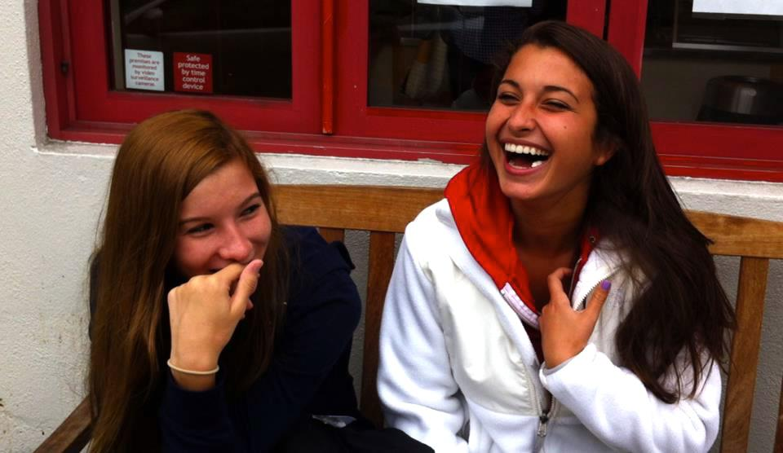

Over the next six months, I counted at least five other teen suicides around the Bay Area. I couldn’t understand why this was happening or why students thought this was an option. I needed answers.  I needed to know how I could help. I needed to know why.

As I looked on the Internet, I found pages and pages of different films on teen suicide, all by adults, none from a teen perspective. I realized if I couldn’t relate to any of these videos, how could a teen in need relate? I began by meeting with organizations, experts, professors, teachers, psychiatrists, and parents to learn more about depression and suicide. NAMOI, Edgewood, Marin Family Service Agency, San Francisco Suicide Prevention, and Grace Magill Project. I took seminars that taught me how to help someone who is suicidal. I became so engulfed in the topics it practically became what I knew best. But, I still didn’t know why. I knew all the facts are about depression and suicide. But I couldn’t feel it. I needed to hear from someone who’d been there.

Talking with students who have thought about suicide, I learned what depression really is. I meet Quinn again and again with each of them. But through their stories, I have healed as I now have a bigger understanding of what my peers have gone through.

Each teen I interviewed had a very vivid description of depression that was unique to the experience they endured whether it was abuse, a traumatic event or sometimes just the pressure of school. Regardless of their reasons, they all shared the same pain. They were immensely different in regards to their interests, family background, and really just who they are: an artist, a model, an athlete, a boy scout, a musician, someone with anxiety, someone who suffered from anorexia, a drug user. However, no matter how different they are, they all said the same thing. They felt alone with no one to talk to.

Not Alone will show the realness of teen depression in our society. I want to encourage students to reach out and know that they are **not alone.** Lastly, it is my wish to bring together those who feel isolated, open up the eyes of those who are unaware of the severity, and give a sense of hope for those who feel discouraged

Through my own experience and the stories of teens, don’t wait. Don’t wait to see if your friend’s mood will change in the next month. Don’t wait to talk to a friend. What’s the worst thing that could happen with just a simple question, how are you today? Tell your friends you care about them and just listen. Know that your friends are there for you to reach out. We have the power to help each other more than any expert or professional can. We are the front line and we need to act now. I wish I had.



Jacqueline Monetta & Kiki Goshay